 | 16.1.7 Editors - Dope Sheet - Key Menu
Table of content
Dopesheet Editor - Key Menu 1
Transform 2
Grab/Move 2
Extend 2
Slide 2
Scale 2
Last Operator Transform 2
Values 2
Axis 2
Orientation 2
Mirror Editing 3
Proportional editing 3
Proportional Falloff 3
Proportional Size 3
Connected 3
Projected(2D) 3
Snap 3
Mirror 3
Insert Keyframes 3
Jump to Keyframes 3
Copy Keyframes 3
Paste Keyframes 4
Paste Flipped 4
Duplicate 4
Delete Keyframes 4
Delete Breakdown Frames 4
Clean Keyframes 4
Clean Channels 4
Bake Keyframes 4

Dopesheet Editor - Key Menu
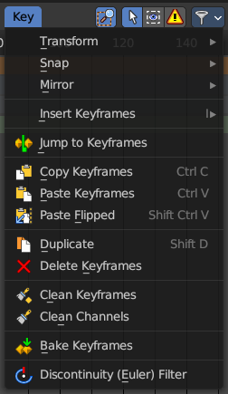
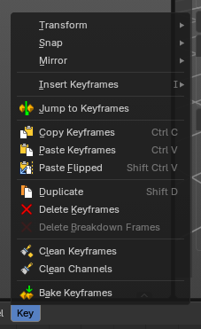
The key menu contains functionality to manage the keyframes.
The menu exist in all modes. In Grease Pencil mode it contains not so much functionality.
The grease pencil object is a special object in this regards. It can have keyframes at an object level. And keyframes at a stroke level, which the grease pencil mode is meant for.

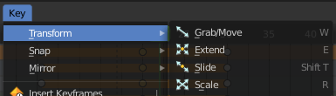
Transform

Grab/Move
Moves the selected keyframe(s).

Extend
Moves the last keyframes of the selection.

Slide
Slides a selected keyframe between two other keyframes.

Scale
Scales the selected keyframes. You need to have more than one keyframe selected.

Last Operator Transform
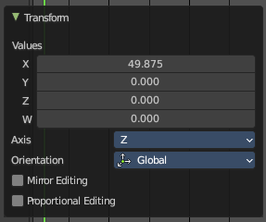
The last operator is nearly equal for the transform operations above.

Values
The transform values.

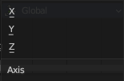
Axis
Which axis is up.

Orientation
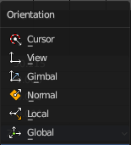
Choose the orientation in which the transform should happen.

Mirror Editing
Just with Grab/Move. Allow mirror edit the transform.

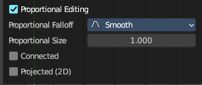
Proportional editing
Enables proportional editing. Activating proportional editing reveals further settings.

Proportional Falloff
Adjust the falloff methods.

Proportional Size
See and adjust the falloff radius.

Connected
The proportional falloff gets calculated for connected parts only.

Projected(2D)
The proportional falloff gets calculated in the screen space. Depth doesn't play a role. When it's in the radius, then it gets calculated.

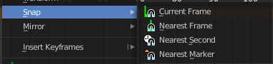
Snap
Snaps the selected keyframes by the chosen method.

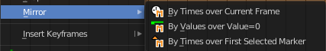
Mirror
Flips the selected keyframes over the current frame position.

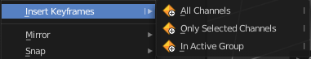
Insert Keyframes
Choose a method how to insert a new keyframe at the current frame position.

Jump to Keyframes
Sets the frame marker at the average position of the currently selected keyframes.

Copy Keyframes
Copy selected keyframes.

Paste Keyframes
Pastes copied keyframes.

Paste Flipped
Pastes copied keyframes, but flipped.

Duplicate
Duplicate selected keyframes.

Delete Keyframes
Deletes selected keyframes.

Delete Breakdown Frames
Remove breakdown frames generated by interpolating between two grease pencil frames.
Note: Grease Pencil operator object only.

Clean Keyframes
Simplify FCurces by deleting keyframes that are close to each other in all channels

Clean Channels
Simplify FCurces by deleting keyframes that are close to each other in selected channels.

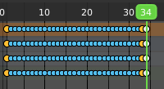
Bake Keyframes
Adds keyframes at every unit between the selected keyframes.

